11.52: a) Finding torques about the hinge, and using L as the length of the bridge and 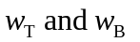for the weights of the truck and the raised section of the bridge,

, so

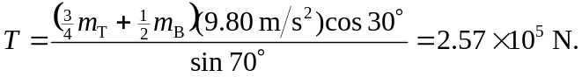

b) Horizontal: 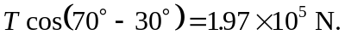Vertical: